State of charge estimation based on EKF and FBG data driven methods
ABSTRACT
State of charge (SOC) estimation is crucial for battery management systems (BMS) in electric vehicles (EVs) to optimize energy use and power distribution. This study compares two SOC estimation methods for lithium iron phosphate (LFP) batteries: the extended Kalman filter (EKF) and a data-driven approach using fiber-optic sensor data. While the EKF, a model-based method, works well in ideal conditions, it struggles with non-linearities, aging, and environmental variations. The data-driven approach, leveraging insights from fiber-optic sensors, provides a more accurate and adaptive solution. Results show the EKF achieves 8.61% RMSE, while the data-driven method achieves 4.51% RMSE, demonstrating its superior accuracy and adaptability. This study emphasizes the potential of data-driven approaches to improve BMS reliability and efficiency, enhancing the sustainability of EV technologies.

INTRODUCTION
Accurate state of charge (SOC) estimation in lithium-ion batteries, particularly lithium iron phosphate (LFP) cells, is critical for optimal performance and longevity of electric vehicles (EVs) [1][2]. As the automotive industry transitions to electrification, the demand for advanced and reliable battery management systems (BMS) has increased [3]. SOC, which represents the remaining battery capacity, is essential for efficient energy use, preventing overcharging or over-discharging, and extending battery life [4][6].
Traditional SOC estimation methods often rely on model-based approaches, with the extended Kalman filter (EKF) being one of the most widely used techniques [2][9]. The EKF is effective in handling non-linear systems and performs well under varying conditions [7], but its accuracy depends on the underlying battery model and its ability to capture complex behaviors [6][9]. LFP batteries, known for safety and long cycle life, present challenges for SOC estimation due to their flat open-circuit voltage and significant polarization differences under different temperatures [1]. These characteristics complicate voltage-based modeling, often leading to errors that affect BMS performance [6].
Recent advancements in fiber optic sensor technology offer a more precise approach to battery monitoring [4][8]. Fiber optic sensors, which measure parameters like temperature gradients, strain, and refractive index changes, are embedded in battery cells and provide direct data that can be correlated with SOC. These sensors offer high sensitivity, immunity to electromagnetic interference, and the ability to measure multiple parameters simultaneously, offering advantages over traditional electrical sensors.
Integrating these sensors with data-driven estimation methods provides a promising solution to overcome the limitations of model-based techniques like the EKF [3][7]. Machine learning algorithms, combined with fiber optic sensor data, enable the development of adaptive and accurate SOC estimation methods that address non-linearity, aging effects, and environmental changes [5][10].
This study compares the performance of the EKF with a novel data-driven approach utilizing fiber optic sensor data for SOC estimation in LFP batteries. By evaluating the strengths and limitations of each method under various conditions, the study aims to advance the development of more reliable and efficient BMS for EVs. The findings could improve range estimation, optimize charging strategies, and enhance overall vehicle performance [3][5].

DATASET DESCRIPTION
The dataset includes HPPC and aging data from C/20 cycling of LFP batteries. HPPC data captures power performance, while aging data tracks degradation. The ECM in Figure 1(b) includes a voltage source (V_{OC}), internal resistance (R₀), and an RC pair for diffusion voltage [11][12]. The nonlinear V_OC-SOC relationship is shown in Figure 1(a) from a C/20 charge-discharge test at 25°C. The ECM model [11] is:
${\frac{d}{dt}V}_{t}=-\frac{1}{R_{1}C_{1}}V_{t}+\frac{R_{0}}{R_{1}C_{1}}i; V_{t}=V_{b}-R_{0}i-V_{OCV}; \frac{d}{dt}z=-\frac{1}{Q}i$
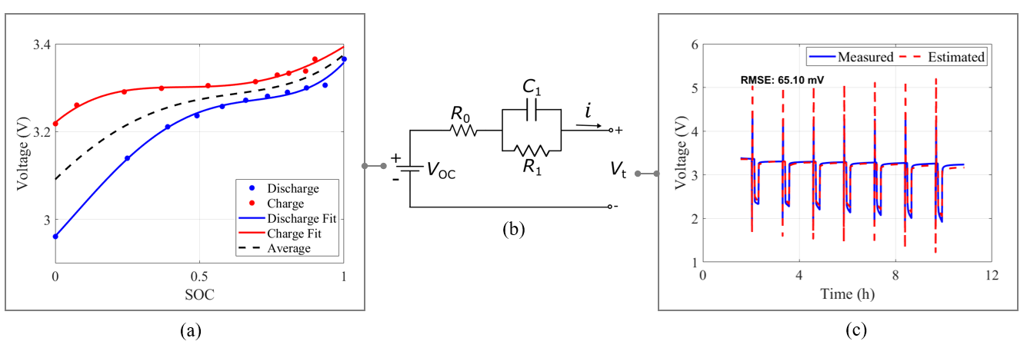
Fig. 1. (a) Voltage vs. SOC curve with fitted curves; (b) ECM with V_OC, R0, and R1-C1 pair; (c) Measured vs. estimated voltage during HPPC cycles, RMSE = 65.10 mV.
In this model, V_{OC} is the open-circuit voltage, V_{t} is the terminal voltage, i is the current, and R₀, R₁, and C₁ model the diffusion voltage [2]. Table 1 lists the parameters, with Figure 1(c) showing a close match between measured and estimated terminal voltage.

METHODOLOGY

Extended Kalman filter
The Extended Kalman Filter (EKF) is a sophisticated state estimation algorithm that handles nonlinear systems by linearizing around the current state estimate. For state of charge (SOC) estimation in battery systems, the EKF utilizes discrete-time nonlinear state-space equations, as outlined in [12]. By combining prior predictions with current measurements and weighting them according to their respective uncertainties, the EKF enables dynamic adjustments to changes in system behavior and measurement accuracy.

Data driven SOC estimation using Optic Sensor
In this study, Gaussian Process Regression (GPR) was used to estimate battery SOC from Fiber Bragg Grating (FBG) sensor data, which measures wavelength shifts due to strain and temperature changes. These shifts were used as input features, with SOC as the target output. The GPR model, using a Radial Basis Function (RBF) kernel, captures the non-linear relationship between wavelength data and SOC, improving accuracy and quantifying uncertainties. Trained on experimental data across varying conditions, this method addresses battery non-linearity and dynamics, building on prior GPR applications in non-linear regression [13] and extending it to sensor data integration for battery management systems.

RESULTS AND DISCUSSION
The dataset includes time, voltage, and wavelength measurements from charge-discharge cycles of a 2.75 mAh lithium-ion coin cell at 25°C, as shown in Figure 2(a). Figure 2(b). illustrates a discharge pulse during the HPPC cycles, with values calculated similarly to [11-12]. ECM parameters, identified as outlined in Section 2, are listed in Table 1.
TABLE 1: PARAMETERS IN BATTERY EQUIVALENT CIRCUIT MODEL
Parameter | Symbol | Value
Capacitance | C₁ | 9.01 F
Resistance | R₁ | 99.93 Ω
Resistance | R₀ | 486.74 Ω
Capacity | Q | 2.75 mAh
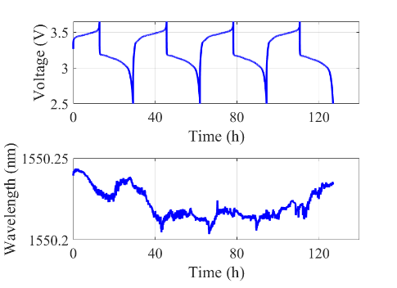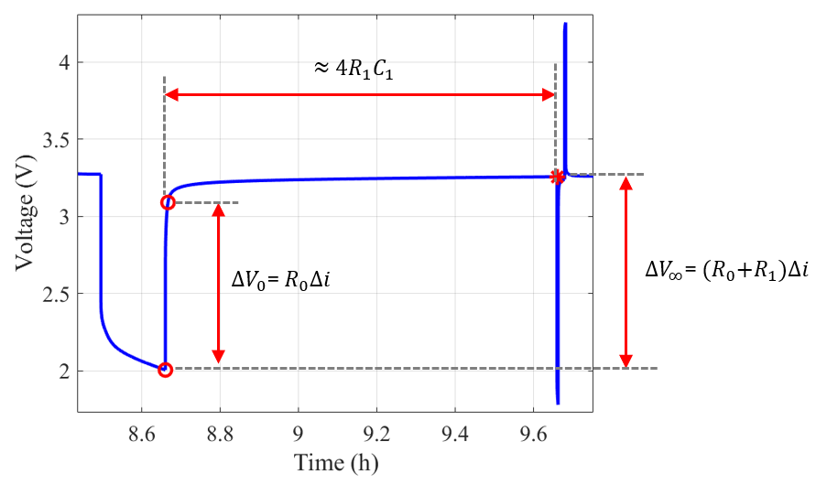
(a) (b)
Fig. 2. (a) Voltage and wavelength profiles during C20 cycles. (Top) Voltage and (Bottom) Wavelength over time. (b) ECM parameter identification using HPPC discharge experimental data.
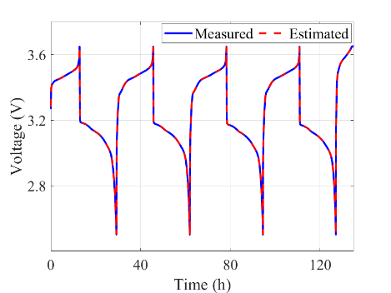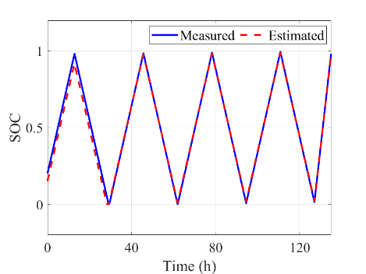
(a) (b)
Fig. 3. EKF approach for SOC estimation (a) SOC prediction, (b) Terminal voltage,
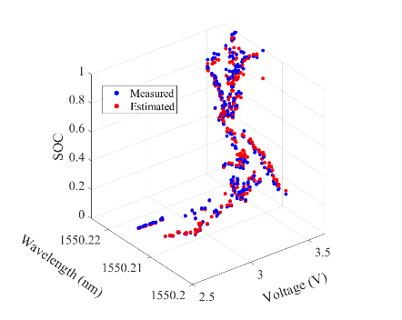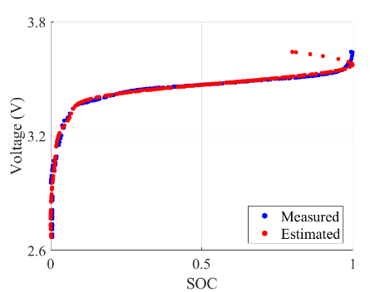
(a) (b)
Fig. 4. FBG data-driven approach for SOC estimation. (a) 3D plot of wavelength, voltage, and SOC with measured (blue) and estimated (red) data. (b) Voltage vs. SOC for measured and estimated values.

In this study, the EKF was utilized to estimate SOC of the battery. Figure 3(a) presents a comparison between the measured and EKF-estimated terminal voltages, showing a strong correlation, which confirms the model’s effectiveness in accurately capturing battery behavior. The model's performance was assessed by comparing the measured and estimated SOC values, yielding a RMSE of 8.61%. This result indicates that the EKF provides reliable SOC estimation despite the complexities inherent in battery dynamics. As demonstrated in Figure 3(b), the close alignment between the measured and estimated SOC further underscores the robustness of the EKF approach.
In this study, a FBG data-driven approach was used to predict the state of charge (SOC) of the battery, resulting in an RMSE of 4.51%. Figure 4(a) shows the 3D plot of wavelength, voltage, and SOC, with measured (blue) and estimated (red) data closely aligning, indicating the model’s accuracy in capturing the SOC from the sensor data. Figure 4(b) presents the voltage vs. SOC plot, where the measured and estimated values exhibit a strong correlation, demonstrating the model's effectiveness. However, in the final segment of the plot, the GPR kernel fails to fit the data accurately at the higher voltage values due to the absence of corresponding data points in that range. This issue can be mitigated by separately fitting the top region, excluding the lower values that disproportionately influence the predictions, resulting in a more accurate fit at higher SOC levels.
The comparison between true and estimated SOC over C/20 cycles shows a strong match with EKF estimates, demonstrating its effectiveness in tracking battery dynamics under varying conditions and noise. However, at higher noise levels, the EKF struggles, with minor deviations during rapid transitions. These findings highlight the EKF’s suitability for real-time SOC estimation, though improvements in model fidelity and noise handling are needed. The (1) EKF and (2) FBG data-driven approaches correspond to two-dimensional and three-dimensional SOC estimation, respectively. The FBG method achieves a 4.51% RMSE, immune to noise and EMI, while the EKF's performance is reduced by noise and non-linear dynamics, leading to higher RMSE.

CONCLUSIONS and FUTURE WORK
This study compares SOC estimation methods for LFP batteries using EKF and FBG data-driven approaches. The FBG method offers superior accuracy and adaptability, particularly in handling nonlinearities and dynamic conditions. Its optical, galvanically insulated nature makes it immune to electromagnetic interference, enhancing its robustness for real-time SOC estimation in noisy environments. Future work should apply this model to real-world data, such as EV data, to evaluate its performance in practical applications. Additionally, exploring hybrid EKF-FBG approaches and integrating machine learning will enhance the model's accuracy and adaptability

REFERENCES
[1] Z. Zhang et al., "High-precision and robust SOC estimation of LiFePO4 blade batteries based on the BPNN-EKF algorithm," Batteries, vol. 9, no. 6, p. 333, Jun. 2023. doi: 10.3390/batteries9060333.
[2] K. Rupanwong, S. Kittiratsatcha, and S. Polmai, "Comparison of extended Kalman filter and long short-term memory neural network for state of charge estimation of lithium-ion battery," in Proc. IEEE Transp. Electrif. Conf. Expo (ITEC), pp. 55-58, Oct. 2023.
[3] F. Mohammadi and R. Rashidzadeh, "An overview of IoT-enabled monitoring and control systems for electric vehicles," IEEE Instrum. Meas. Mag., vol. 24, no. 3, pp. 22-29, May 2021.
[4] Y. D. Su, Y. Preger, H. Burroughs, C. Sun, and P. R. Ohodnicki, "Fiber optic sensing technologies for battery management systems and energy storage applications," Sensors, vol. 21, no. 4, p. 1397, Feb. 2021. doi: 10.3390/s21041397.
[5] G. S. Tewolde, "Sensor and network technology for intelligent transportation systems," in Proc. IEEE Int. Conf. Electro/Inf. Technol., pp. 1-5, Oct. 2012.
[6] F. Feng, R. Lu, G. Wei, and C. Zhu, "Online estimation of model parameters and state of charge of LiFePO4 batteries using a novel open-circuit voltage at various ambient temperatures," Energies, vol. 8, no. 4, pp. 2950–2976, Apr. 2015. doi: 10.3390/en8042950.
[7] X. Liu, Q. Li, L. Wang, M. Lin, and J. Wu, "Data-driven state of charge estimation for power battery with improved extended Kalman filter," IEEE Trans. Instrum. Meas., vol. 72, p. 1500910, 2023. doi: 10.1109/TIM.2023.3239629.
[8] L. W. Sommer et al., "Embedded fiber optic sensing for accurate state estimation in advanced battery management systems," in Mater. Res. Soc. Symp. Proc., vol. 1681, 2014. doi: 10.1557/opl.2014.560.
[9] M. Al-Gabalawy, N. S. Hosny, J. A. Dawson, and A. I. Omar, "State of charge estimation of a Li-ion battery based on extended Kalman filtering and sensor bias," Int. J. Energy Res., vol. 45, no. 5, pp. 6708–6726, Nov. 2021. doi: 10.1002/er.6265.
[10] Y. Ko and W. Choi, "A new SOC estimation for LFP batteries: Application in a 10 Ah cell (HW 38120 L/S) as a hysteresis case study," Electronics, vol. 10, no. 6, p. 705, Mar. 2021. doi: 10.3390/electronics10060705.
[11] G. L. Plett, Battery Management Systems: Volume I: Battery Modeling, 1st ed. Austin, TX, USA: PCIM, 2015.
[12] G. L. Plett, Battery Management Systems: Volume II: Equivalent-Circuit Methods, 1st ed. Austin, TX, USA: PCIM, 2016.
[13] C. E. Rasmussen and C. K. I. Williams, Gaussian Processes for Machine Learning. Cambridge, MA, USA: MIT Press, 2005.

